
RED RIVER BOWMEN ARCHERY CLUB, INC. ADULT MEMBERSHIP APPLICATION
PLEASE PRINT
Name: ________________________________________
Address: _____________________________________
City: ____________________ St: _____ Zip: ________
CELL PHONE (TEXT) _________________________
Work Ph: ______________ Home Ph: _____________
E-mail: _______________________________________
If Family Membership, list members & birth date:

FEES:
Family Membership: $178.00 ________ (Aug. 1 – July 31)
Single Membership: $128.00 ______ (Aug. 1 – July 31)
NOTE: Qr code used-send completed application by email (redriverbowmenarcheryclub@gmail.com), text (318.572.6102).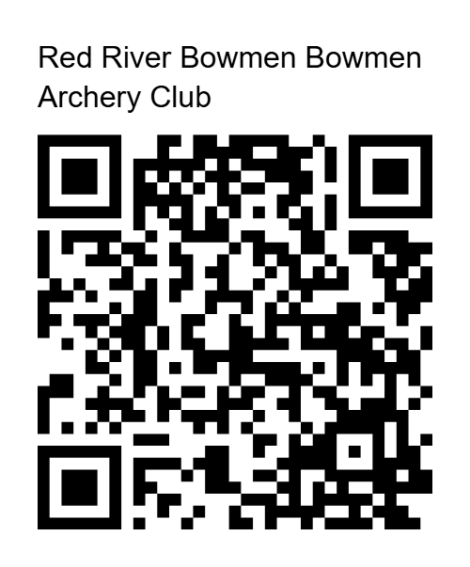

1st Time Single/Family Membership $78.00____ (offered Feb. 1, expires July 31)
Please list any archery & youth affiliations & who referred you:

MAKE CHECKS PAYABLE TO: Red River Bowmen Archery Club Mail Application with funds to: RRBAC, 8018 Dogwood Trl., Haughton, La. 71037 Questions, contact Emma Brown, Sec., 318.572.6102

IF ACCEPTED, I AGREE TO SIGN A RRBAC WAIVER/RELEASE OF LIABIITY. I AGREE TO ABIDE BY THE RULES AND REGULATIONS OF RRBAC AND WILL VOLUNTEER FOR WORK DETAILS AND ASSIST IN THE MAINTENANCE OF THE CLUB FACILITIES. Questions concerning work details can be addressed to RRBAC Board/Officers (contact information on website & bulletin board).
Signature __________________________________Date: ___________

RED RIVER BOWMEN ARCHERY CLUB, INC. WAIVER AND RELEASE OF LIABILITY READ BEFORE SIGNING
In consideration of being allowed to participate in any way in RED RIVER BOWMEN ARCHERY CLUB, INC. events and activities, the undersigned acknowledges, appreciates, and agrees that:

- The risk of injury from archery and other known and unknown events and activities and/or the use of related buildings, structures, equipment, automobiles, firearms, weapons, ATVs, boats, tree stands, roads, bodies of water, land, and all other real and personal property, whether owned by archery club or others is significant, including the potential for permanent paralysis and death, and while particular rules, equipment, and personal discipline may reduce this risk, the risk of serious injury exists: and,
- I acknowledge and agree that the use of archery equipment, firearms, and other weapons by myself or others on club premises or otherwise are inherently dangerous and high risk activities whether such archery equipment , firearms, or weapons are discharged by myself or others; and,0
- I KNOWLING AND FREELY ASSUME ALL SUCH RISKS, both known and unknown, EVEN IF ARISING FROM THE NEGLIGENCE OF
THE RELEASEES or others, and assume full responsibility for my participation; and,
- I willingly agree to comply with the stated and customary terms and conditions for participation. If however, I observe any unusual significant hazard during my presence or participation, I will remove myself from participation and bring such to the attention of the nearest official immediately; and,
- I for myself and on behalf of my heirs, assigns, personal representatives, and next of kin, HEREBY RELEASE AND HOLD HARMLESS RED RIVER BOWMEN ARCHERY CLUB, INC. its officers, directors, officials, agents, employees, owners, and lessors of real property and personal property used to conduct the events and activities (“RELEASEES”), WITH RESPECT TO ANY AND ALL INJURY, DISABILITY, DEATH, or loss or damage to person or property, WHETHER ARISING FROM THE NEGLIGENCE OF THE RELEASEES OR OTHERWISE, TO THE FULLEST EXTENT PROVIDED BY LAW.
- I FURTHERMORE ATTEST THAT I HAVE NOT KNOWNINGLY BEEN EXPOSED TO COVID-19 OR ANY OTHER INFECTIOUS DISEASE WITHIN THE PAST FOURTEEN (14) DAYS AND THAT I AM NOT SHOWING SYMPTOMS OF ANY SUCH DISEASE. I further agree
to abide by any current social distancing precautions established by RED RIVER BOWMAN ARCHERY CLUB, INC., and/or the political jurisdiction with authority over the matter.

I HAVE READ THIS RELEASE OF LIABILITY AND ASSUMPTION OF RISK AGREEMENT, FULLY UNDERSTAND ITS TERMS, UNDERSTAND THAT I HAVE GIVEN UP SUBSTANTIAL RIGHTS BY SIGNING IT, AND SIGN IT FREELY AND VOLUNTARILY WITHOUT ANY INDUCEMENT.

Participant’s Name ________________________________________

Participant’s Signature___________________________________ Date Signed ____________________

FOR PARTICIPANTS OF MINORITY AGE
(UNDER AGE 18 AT THE TIME OF PARTICIPATION)
This is to certify that I, as parent/guardian with legal responsibility for this participant, do consent and agree to his/her release as provided above of all the Releasees and for myself, my heirs, assigns, and next of kin, I release and agree to indemnify and hold harmless the Releasees from any and all liabilities incident to my minor child’s involvement or participation in these events and activities and/or the use of related real and personal property as provided above, EVEN IF ARISING FROM THEIR NEGLIGENCE.

Name of Parent/Guardian _______________________________________

Parent/Guardian Signature___________________________________ Date Signed _______________

